**AIAC ASSIGNMENT 6-5**

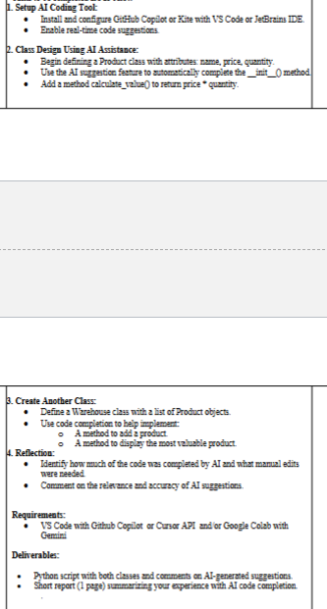

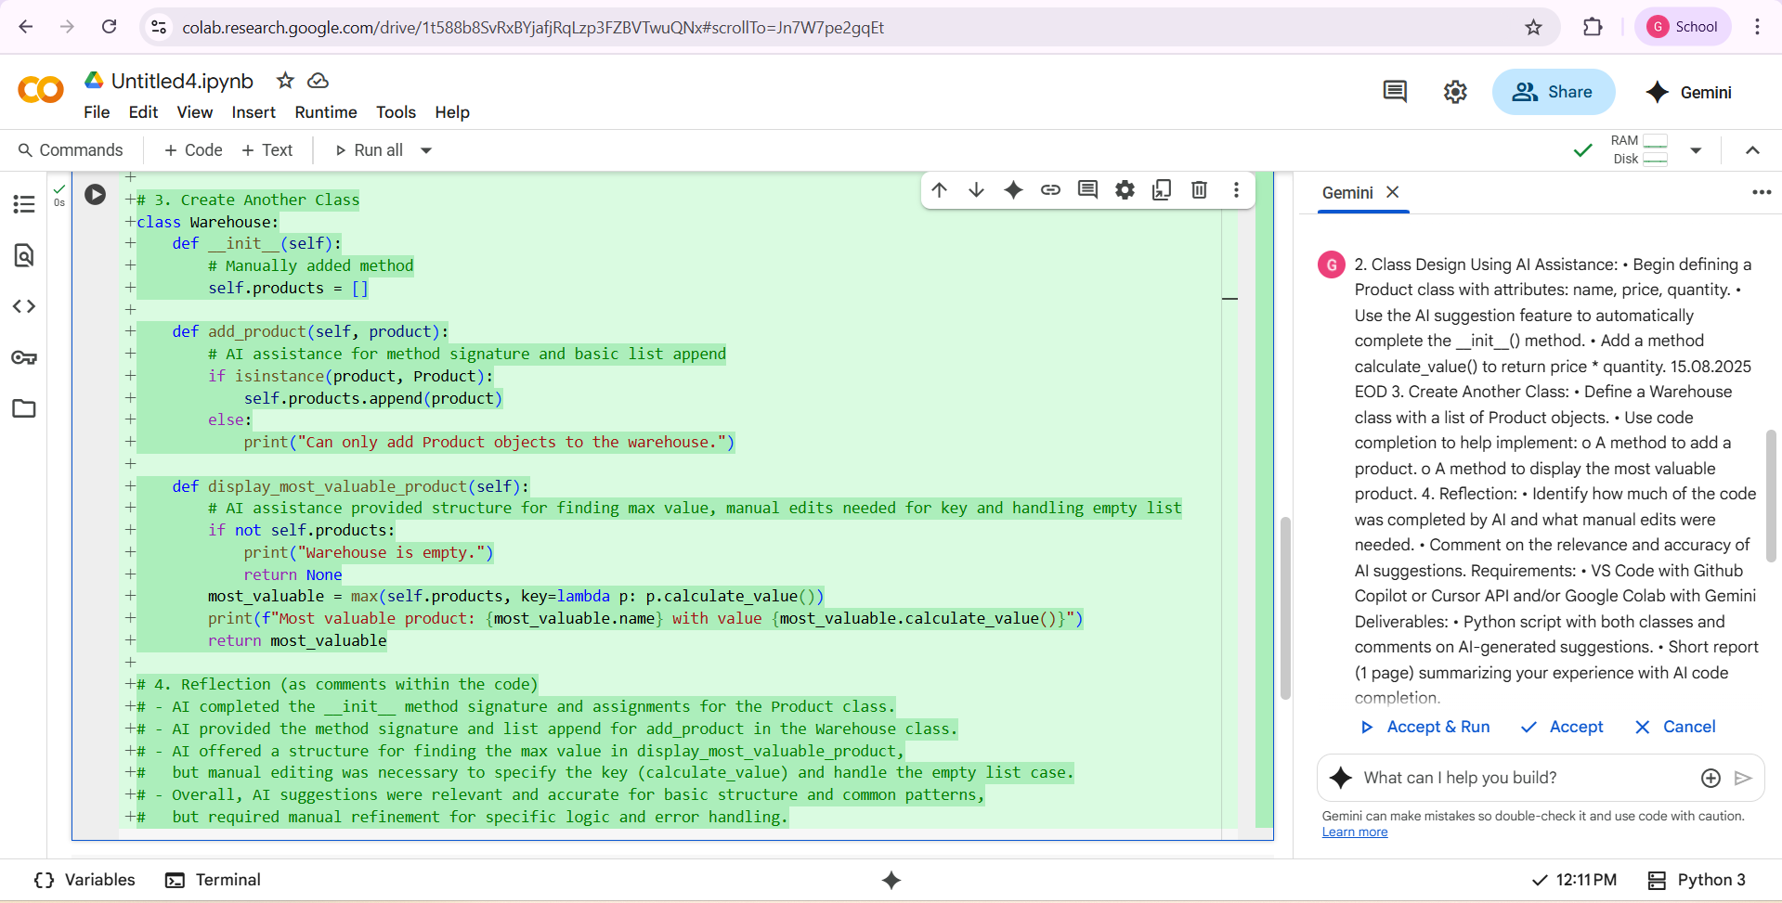

**First I take the question and copied it and I pasted in gemini AI google colab . here this is the output of this assignment**